**ITAHARI NAMUNA COLLEGE**

**ITAHARI-9, SUNSARI**



**LAB REPORT**

**OF**

**Probability and Statistics**

**Submitted by: Submitted to:**

**Name: Ashish Khadka Name: Rajan Poudel**

Class: BCA(3nd semester)

___________________ Signature

Contents

1. Calculate the mean, median and mode by individual series
2. Calculate the mean, median and mode by Discrete series
3. Calculate the mean, median and mode by continuous series
4. Calculate the standard deviation and variance
5. Calculate the Quartile, percentile, and decile
6. Calculate the Harmonic and Geometric mean
7. Calculate the skewness and kurtosis
8. Calculate the steam and leaf display with box plot
9. Calculate the Karl Pearson and spearman correlation coefficient

10, Calculate the regression equation

1. Find the mean, median and mode from following data by individual series.

|  |  |  |  |  |  |  |  |  |
| --- | --- | --- | --- | --- | --- | --- | --- | --- |
| 5 | 7 | 8 | 4 | 9 | 18 | 24 | 29 |  |

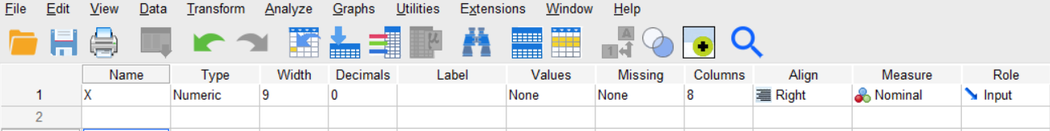

**Step1:** Open the SPSS in variable view mode. Then, create names and labels for the variables. The variable for x is created.

**Step 2:** After creating variable X. Go to the data view and insert the data given.

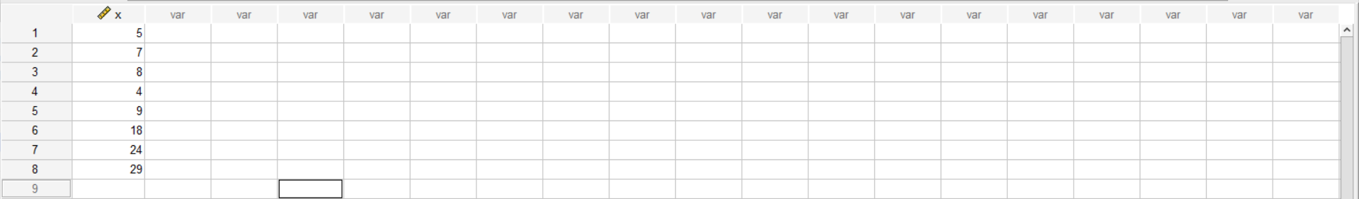

**Step 3:** Go to analyze section then choose descriptive statistics and then click on frequencies.

**Step 4:** Now, select the x and click on the statistics button. Here, mark the checkboxes for Mean, Median and Mode. After selecting then, click “continue” and then “ok.”

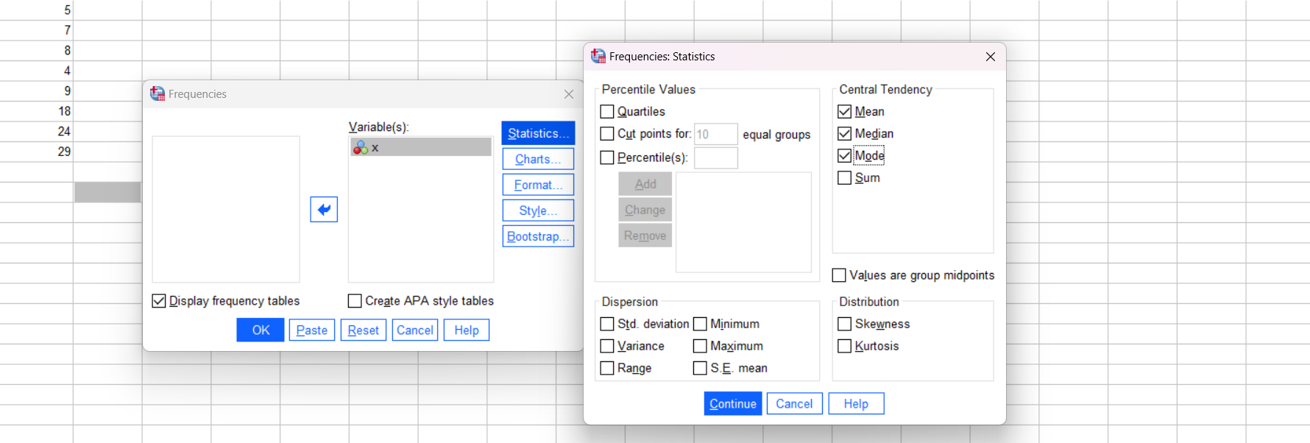

**Step 5:** Then the following output is obtained.

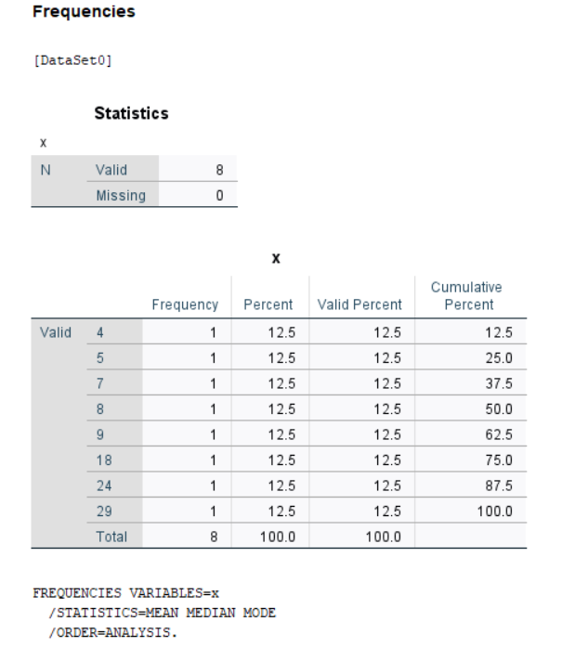 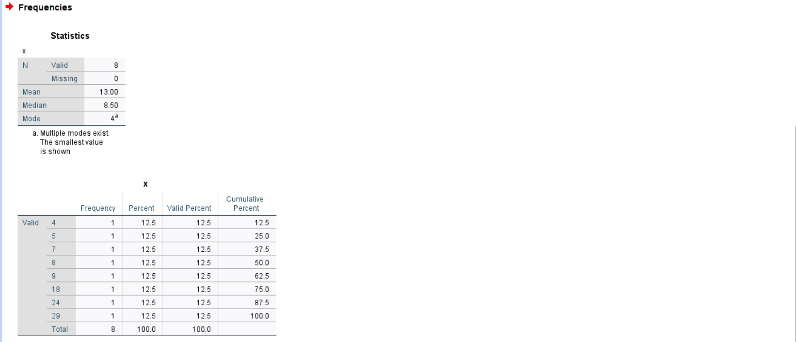

**Result:**

Mean = 13.00

Median = 8.50

Mode = 4

1. 4Calculate the mean, median and mode from the following set of data by discrete series.

|  |  |  |  |  |  |  |
| --- | --- | --- | --- | --- | --- | --- |
| Number | 12 | 14 | 16 | 18 | 20 | 22 |
| Frequency | 3 | 7 | 11 | 6 | 9 | 4 |

**Step 1:** Open the SPSS in variable view mode. Then, create names and labels for the variables. The variable for number and frequency are created.

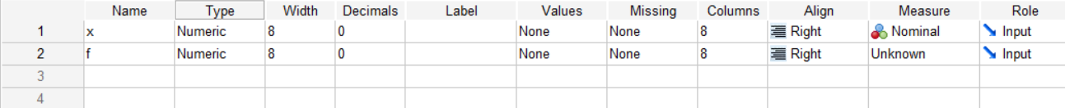

**Step 2:** Once the variables are named and labeled, input data into the data view.

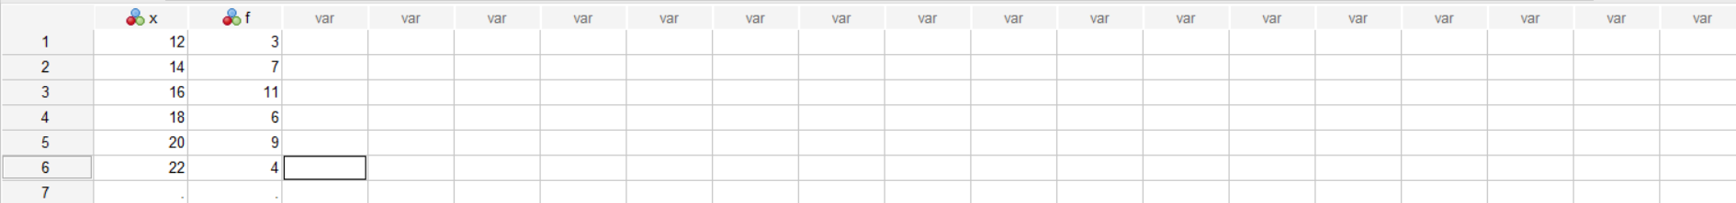

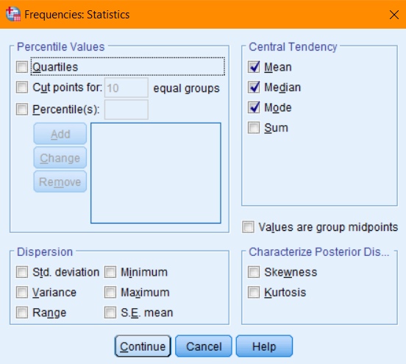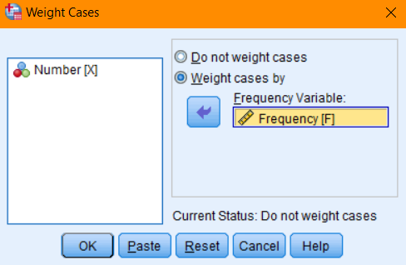**Step 3:** Go to the data section on the Navigation bar, and then choose “weight cases” from the dropdown menu and pick the “f” and designate it as the frequency variable. Click on the “ok” button. Then, navigate to analyze section then choose descriptive statistics and then click on frequencies.

**Step 6:** The the following output is obtained.

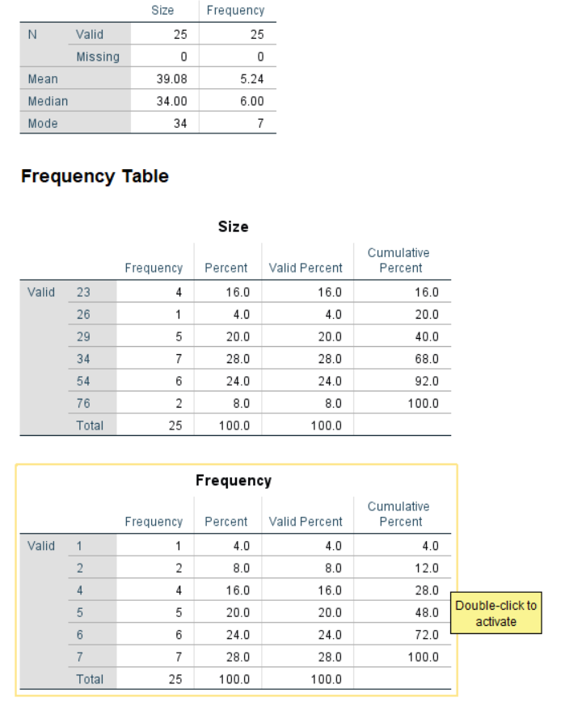

**Result:**

Mean = 5.24

Median = 6

Mode = 7

1. Calculate the mean, median and mode from the following set of data by discrete series.

|  |  |  |  |  |  |  |
| --- | --- | --- | --- | --- | --- | --- |
| Number | 10-20 | 20-30 | 30-40 | 40-50 | 50-60 | 60-70 |
| Frequency | 4 | 5 | 7 | 3 | 1 | 5 |

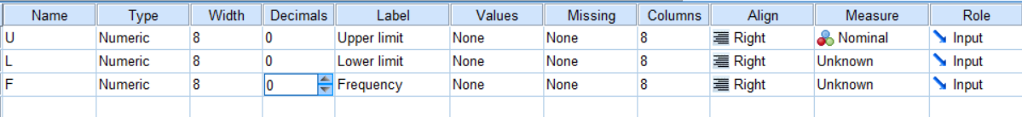**Step 1:** Open the SPSS in variable view mode. Then, create names and labels for the variables. The variable for upper limit, lower limit and frequency are created.

**Step 2:** After the variables are named and labeled, input data into the data view.

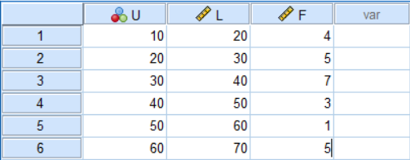

**Step 3:** Go to the data section on the Navigation bar, and then choose “weight cases” from the dropdown menu and pick the “f” and designate it as the frequency variable. Click on the “ok” button.

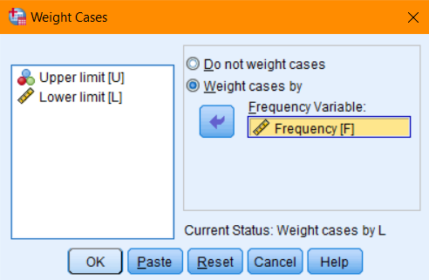

**Step 4:** Now go to transform and select compute variable. To get the midpoint, use the formula (l+u)/2.After that, provide a name for a new target variable and click “ok”.

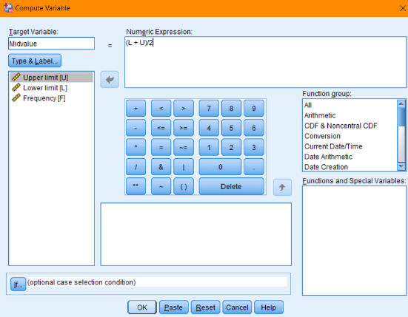

**Step 5:** Navigate to analyze section then choose descriptive statistics then click on frequencies and select mid value and click on ”continue” then “ok”.

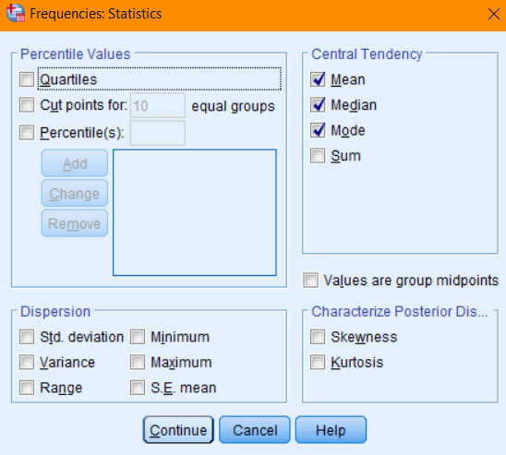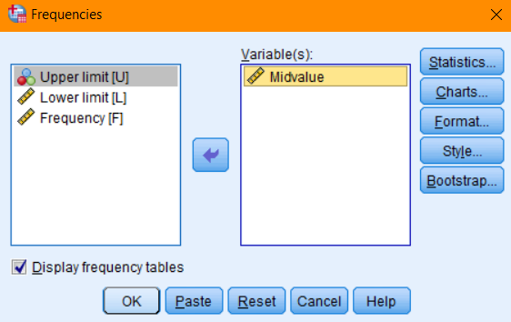

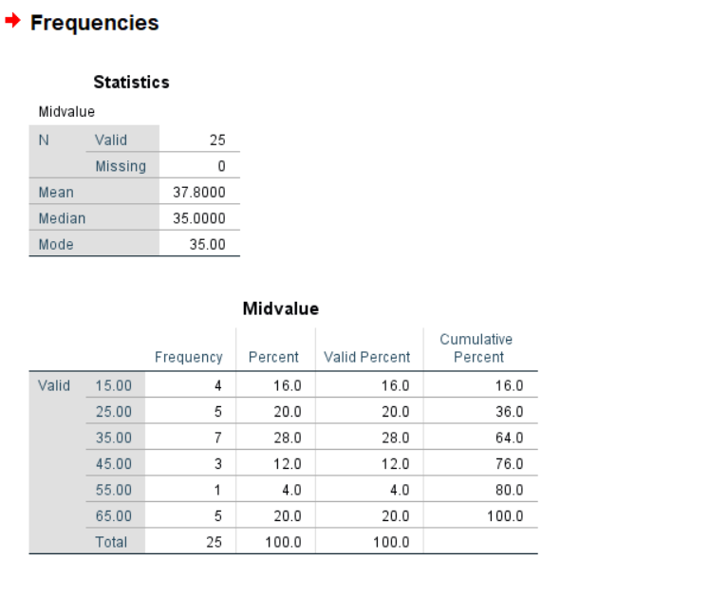**Step 6:** The the following output is obtained.

**Result:**

Mean = 37.8

Median = 35

Mode = 35

4. Calculate the Standard deviation and variance from the following set of data.

|  |  |  |  |  |  |  |
| --- | --- | --- | --- | --- | --- | --- |
| marks | 10-20 | 20-30 | 30-40 | 40-50 | 50-60 | 60-70 |
| Frequency | 3 | 6 | 7 | 3 | 1 | 5 |

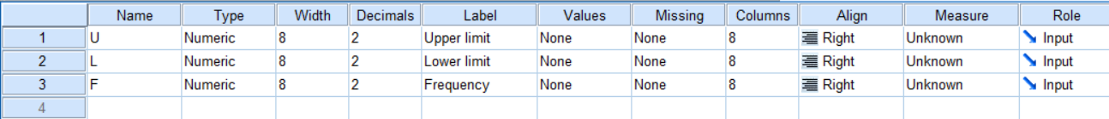**Step 1:** Opening the SPSS in variable view mode. Then, create names and labels for the variables. The variable for marks and frequency are created.

**Step 2:** After the variables are named and labeled, input data into the data view.

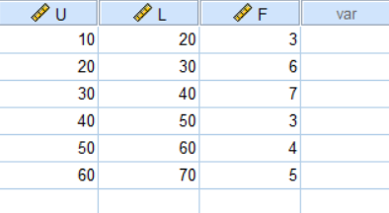

**Step 3:** Go to the data section on the Navigation bar, and then choose “weight cases” from the dropdown menu and pick the “f” (frequencies) and designate it as the frequency variable. Finally, click on the “ok” button.

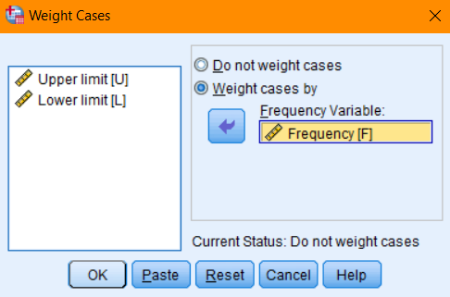

**Step 4:** Now, head to “transform” and select compute variable. Here, we are aiming to determine the midpoint value. To achieve this use formula (l+u)/2. After the formula , provide a name for a new target variable and confirm by clicking “ok.” This action will generate a new variable.

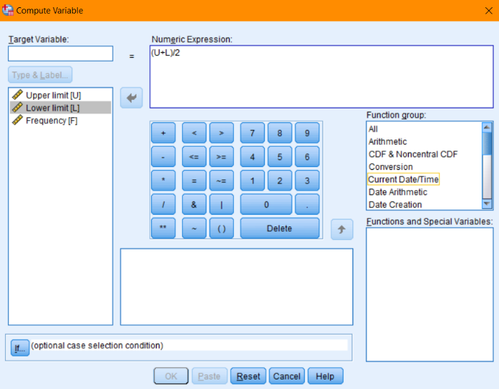

**Step 5:** Next, select “Mid value” and click on the statistics button. Here, mark the checkboxes for Standard Deviation and variance. After selecting them, proceed by clicking “continue” and then “ok.”

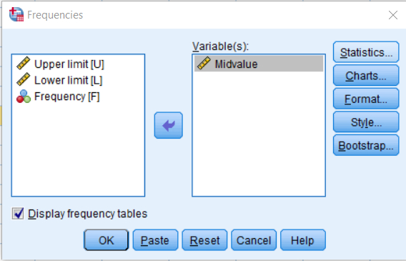

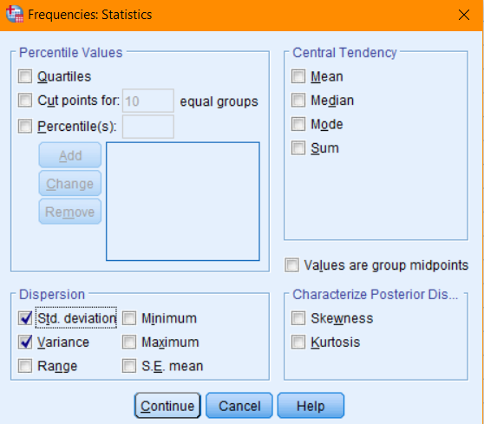

**Step 7:** The following output is obtained.

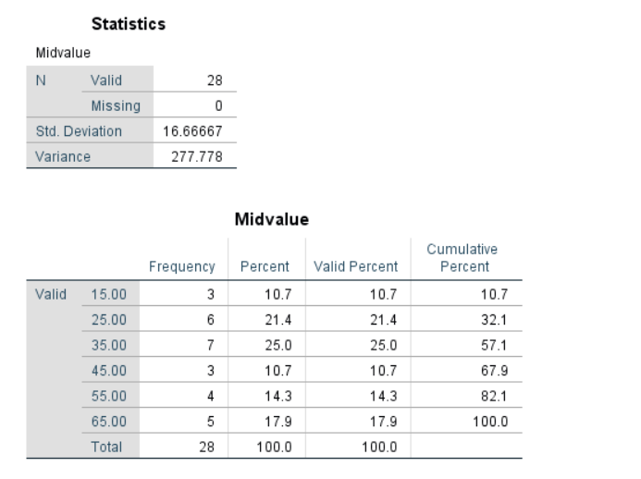

**Result:**

Standard deviation = 16.67

Variance = 277.78

**5. From the data given below, calculate the value of Q1, Q3, D6 and P79.**

|  |  |  |  |  |  |  |
| --- | --- | --- | --- | --- | --- | --- |
| **Size** | **3** | **7** | **6** | **2** | **12** | **17** |
| **Frequency** | **2** | **4** | **11** | **13** | **7** | **5** |

**Step 1:** Open the SPSS in variable view mode. Then, create names and labels for the variables. The variable for size and frequency is created.

**Step 2:** After the variables are named and labeled in the variable view, it’s time to input data into the data view.

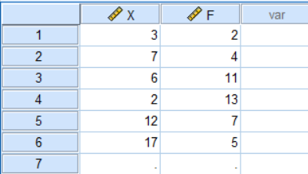

**Step 3:** Go to the data section on the Navigation bar, and then choose “weight cases” from the dropdown menu and pick the “f” (frequencies) and designate it as the frequency variable . Finally, click on the “ok” button. After that, go to analyze section then choose descriptive statistics and then click on frequencies.

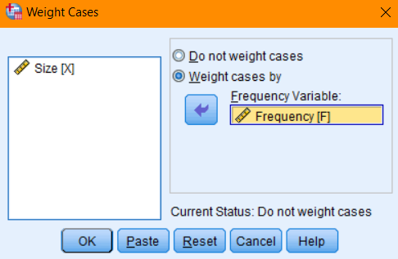

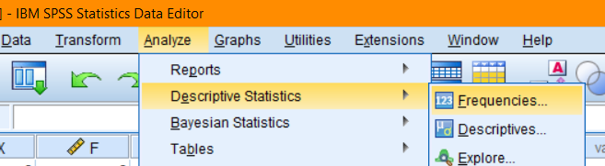

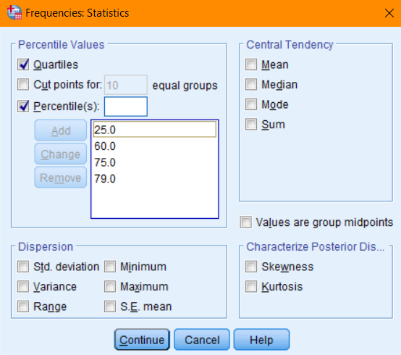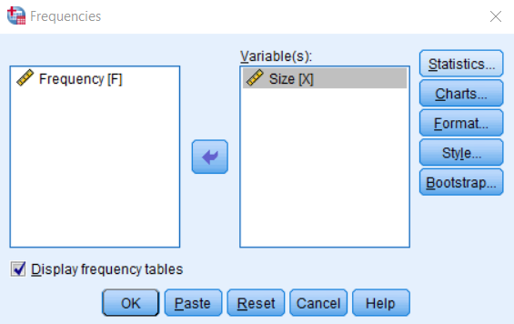**Step 4:** Now, transfer the size (x) to the variable and click on statistics. Then, click on percentiles we can perform quartile and decile. Add the value to percentile which you have to calculate. Then, click on continue and ok button.

**Step 5:** The following output is obtained.

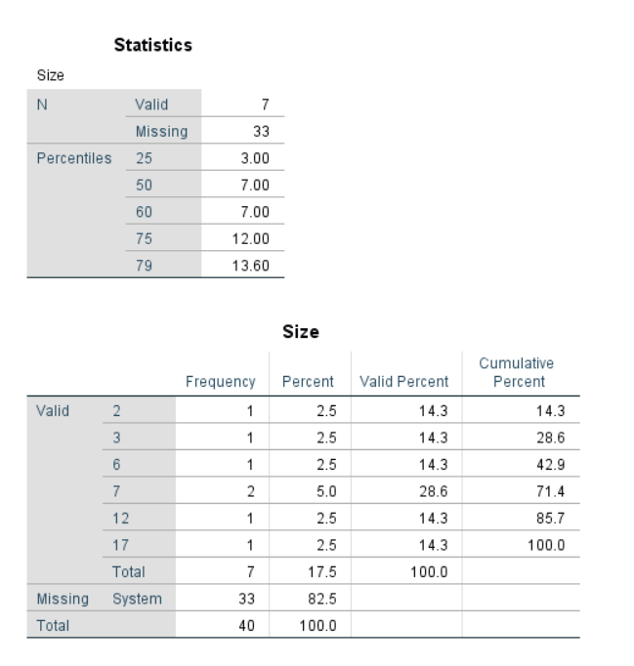

**Result:**

Q1 = 3, Q3=12, D6 = 7, P79 = 13.6

6. **Calculate the Geometric and Harmonic mean from the following set of data.**

|  |  |  |  |  |  |  |  |  |  |
| --- | --- | --- | --- | --- | --- | --- | --- | --- | --- |
| **45** | **55** | **56** | **75** | **67** | **65** | **44** | **77** | **87** | **75** |

**Step 1:** Start by opening SPSS in variable view mode. Then, create names and labels for the variables. The variable for Data is created.

**Step 2:** Once the variables are named and labeled in the variable view, it’s time to input data into the data view.

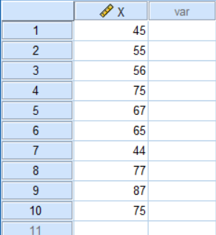

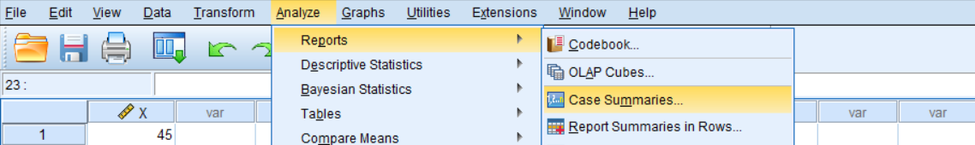**Step 3:** Navigate to analyze section then choose Reports and then click on case summaries.

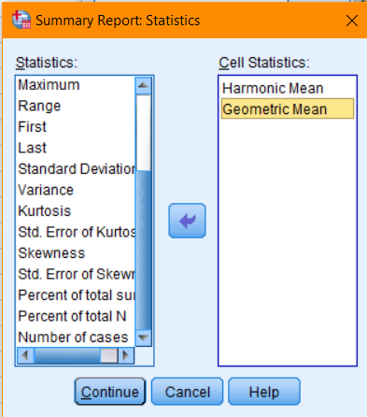**Step 4:** Now transfer x to variable and click on statistics . then, transfer the Harmonic mean and Geometric Mean to cell statistics then click on continue and then click on ok.

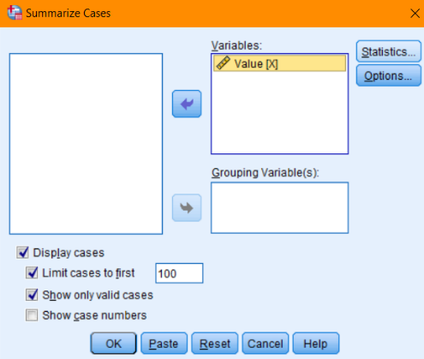

**Step 5:**The following output is obtained.

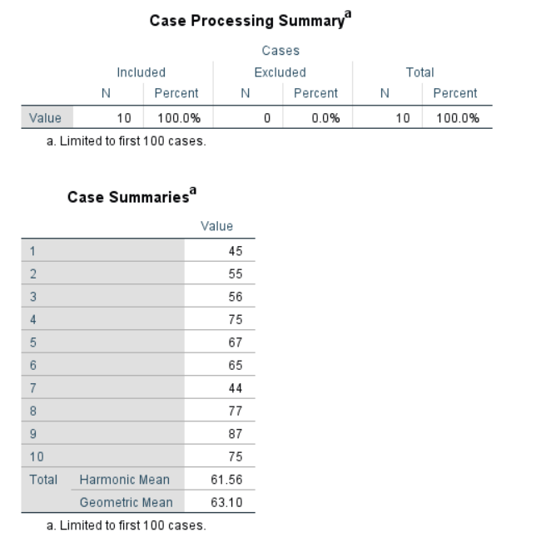

**Result:**

Harmonic mean = 61.56

Geometric Mean = 63.10

7. Calculate the coefficient of skewness and kurtosis from the following data.

|  |  |  |  |  |  |  |  |
| --- | --- | --- | --- | --- | --- | --- | --- |
| X | 11 | 13 | 15 | 16 | 19 | 25 | 30 |
| F | 4 | 8 | 9 | 11 | 16 | 9 | 3 |

**Step 1:** Open the SPSS in variable view mode. Then, create names and labels for the variables. The variable for data and frequency is created.



**Step 2:** Once the variables are named and labeled in the variable view, it’s time to input data into the data view.

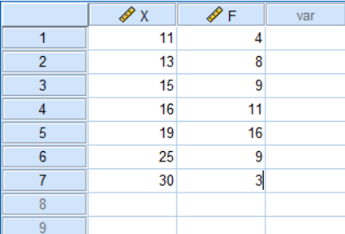

**Step 3:** Navigate to the data section on the Navigation bar, and then choose “weight cases” from the dropdown menu and pick the “f”(frequencies) and designate it as the frequency variable . Finally, click on the “ok” button.

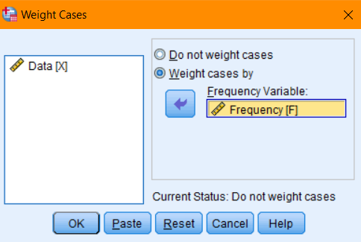

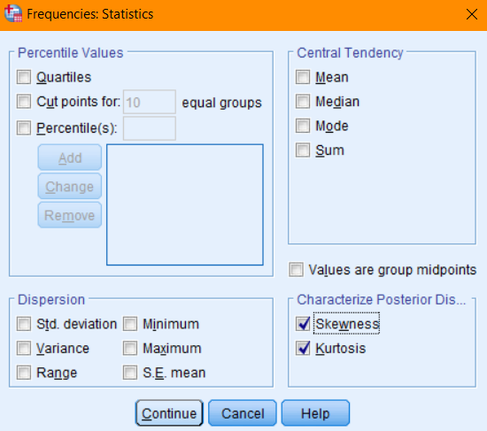**Step 4:** Next, select “Data” and click on the statistics button. Here, mark the checkboxes for skewness and kurtosis. After selecting them, proceed by clicking “continue” and then “ok.”

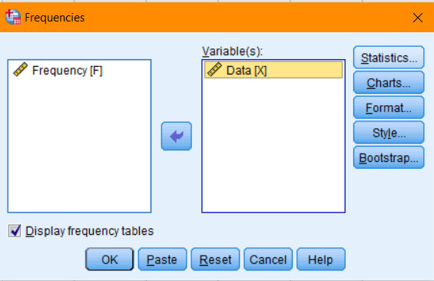

**Step 6:** The following output is obtained.

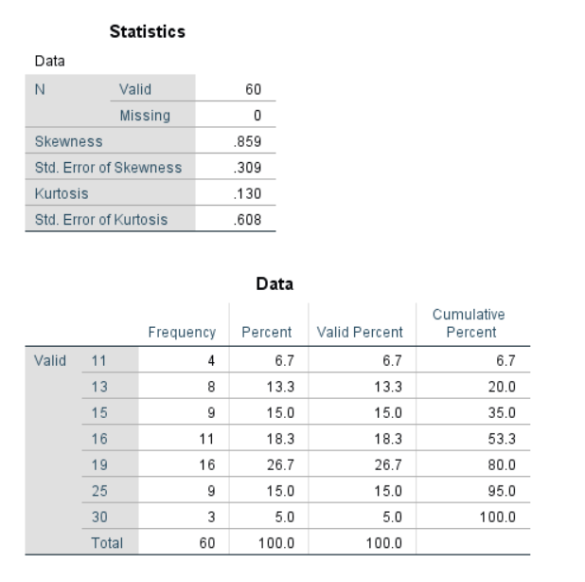

**Result:**

Skewness = 0.859

Kurtosis = 0.130

8.Present the given data using stem and leaf Method.

|  |  |  |  |  |  |  |  |  |
| --- | --- | --- | --- | --- | --- | --- | --- | --- |
| 61 | 55 | 18 | 90 | 32 | 27 | 85 | 26 | 75 |
| 61 | 51 | 88 | 34 | 65 | 48 | 55 | 67 | 50 |
| 62 | 3 | 7 | 81 | 20 | 42 | 68 | 36 | 10 |
| 50 | 68 | 33 | 23 | 64 | 22 | 51 | 82 | 64 |

**Step 1:** Start by opening SPSS in variable view mode. Then, create names and labels for the variables. The variable for values is created.

**Step 2:** Once the variables are named and labeled in the variable view, it’s time to input data into the data view.

**Step 3:** Goto analyze section then choose descriptive statistics then click on Explore.

**Step 4:** Transfer the values to the dependent list and then click on plots. Then tick on factors levels together and stem and leaf and then click on continue and ok button.

**Step 5:** The following output is obtained.

9.Calculate the Karl Pearson’s and Spearman correlation coefficient between number of pages in a book and number of mistakes.

|  |  |  |  |  |  |
| --- | --- | --- | --- | --- | --- |
| X | 12 | 14 | 18 | 19 | 21 |
| F | 3 | 6 | 8 | 9 | 4 |

**Step 1:** Start by opening SPSS in variable view mode. Then, create names and labels for the variables.

**Step 2:** Once the variables are named and labeled in the variable view, it’s time to input data into the data view.

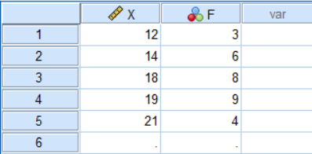

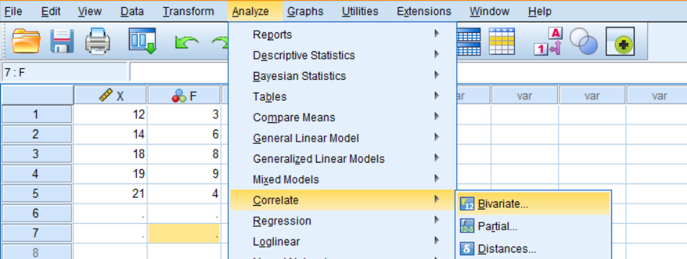**Step 3:**Navigate to analyze section then choose correlate and then Bivariate because it has two variable x and y.

**Step 4:** Now, transfer the x and y to new variable .then, click on the Pearson and spearman on checkboxes then click on “ok” Button.

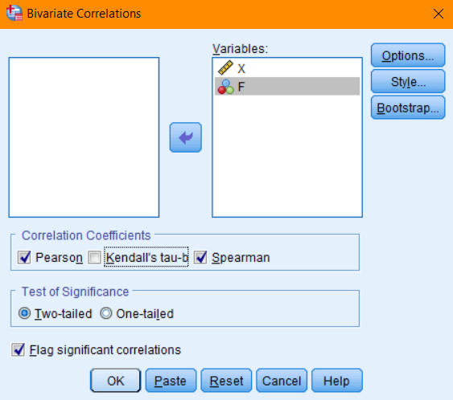

**Step 6:** The following output is obtained.

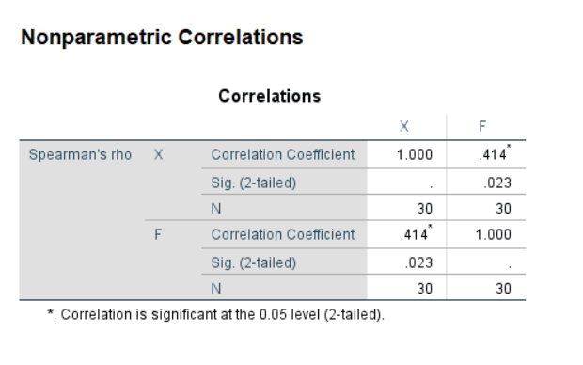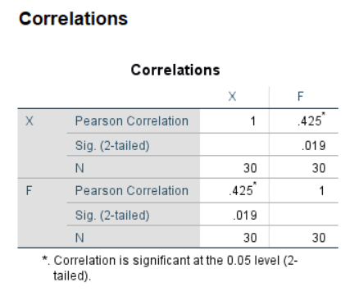

**Result:**

Karl Pearson correlation coefficient =0.425

Spearman’s correlation coefficient = 0.190

10. The following table gives normal weight of a baby during the first six months of life. Determine the regression equation of weight on age and age on weight.

|  |  |  |  |  |  |
| --- | --- | --- | --- | --- | --- |
| Age in months | 0 | 2 | 3 | 5 | 6 |
| Weight on lbs. | 5 | 7 | 8 | 10 | 12 |

**Step 1:** Start by opening SPSS in variable view mode. Then, create names and labels for the variables. The variable for Age in months and weight in lbs. is created.

**Step 2:**Once the variables are named and labeled in the variable view, it’s time to input data into the data view.

**Step 3:**Navigate to analyze section then choose Regression and click on linear.

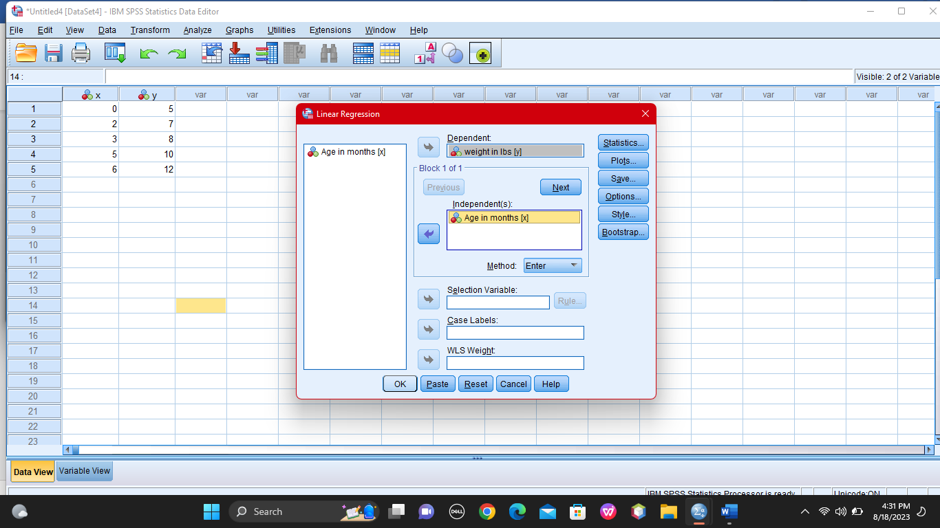**Step 4:** Then, transfer the dependent to dependent variable and independent to independent section. Then, click “ok” button.

**Step 5:** The following output is obtained.

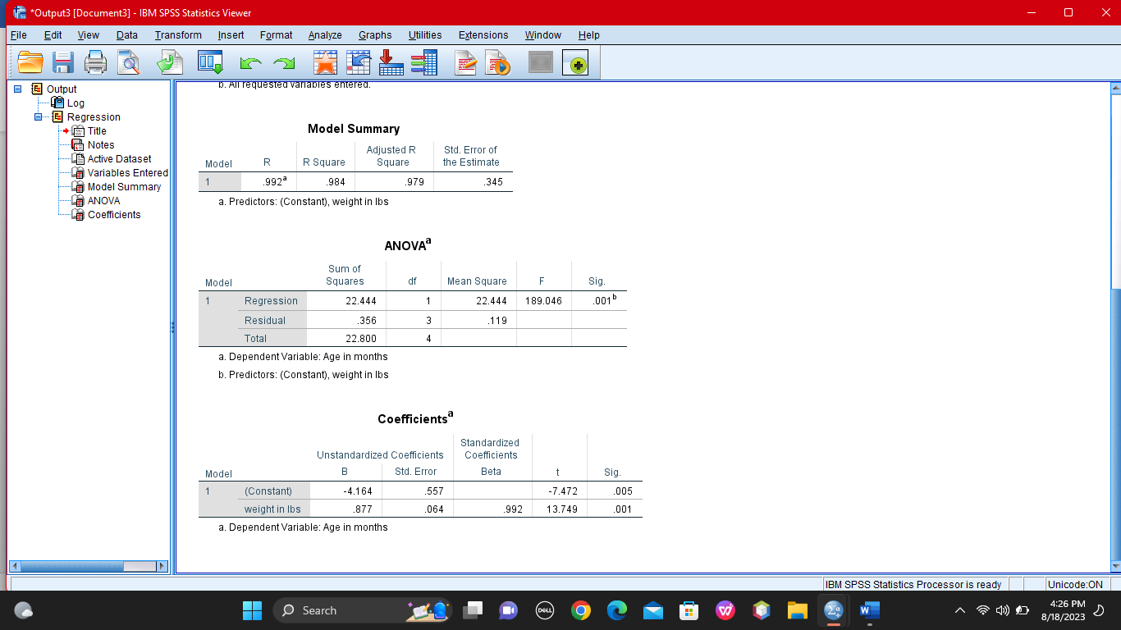

**Result:**

Y on x = 4.8+1.12x

X on y = -4.16+0.87ys